Enterprise Software System Project Details
Mamin Khan 991712023
Malika Muskan 991808527
Saad Mohammad 991739093
Talha Ali 991735398

UML Diagrams

Notesphere Dashboard
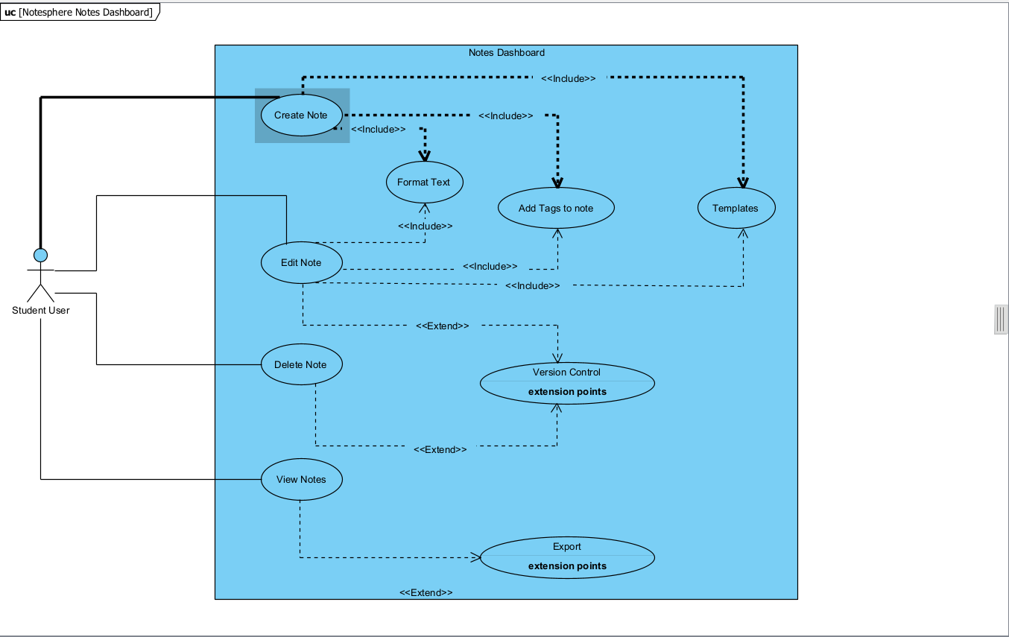

Planner Dashboard
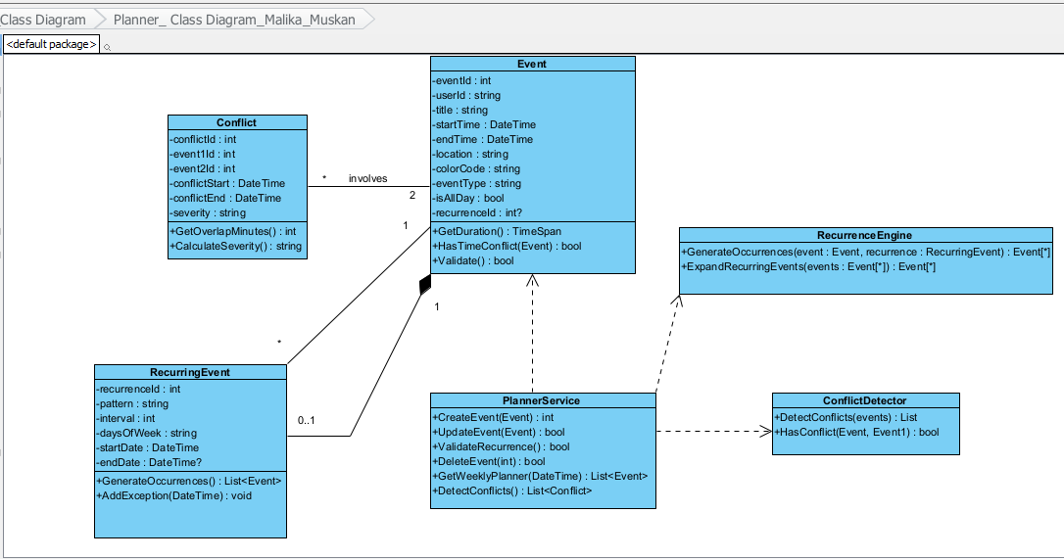

Sharing and Collaboration
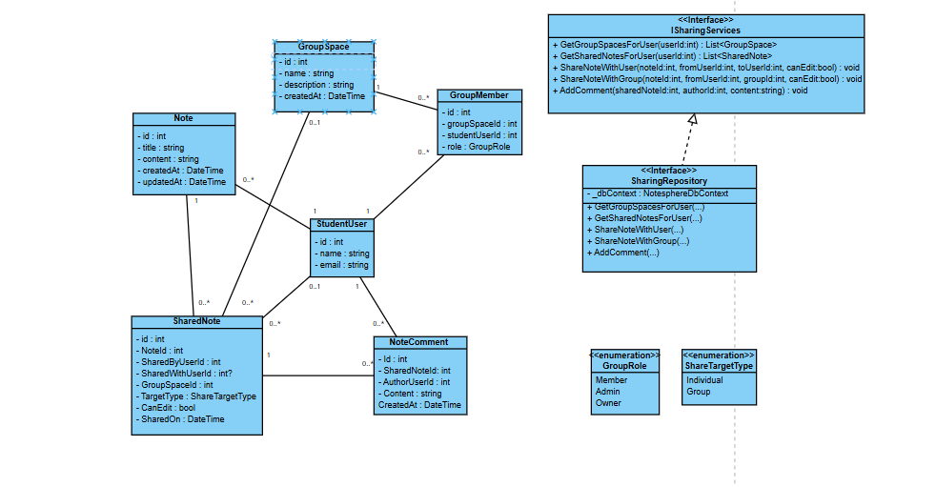

Productivity

